Grade 4 Science Assessment – Sample Questions
- The following image shows a grouping of animals.
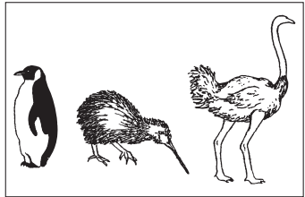
Which of the following images would best fit with the animals above?

- 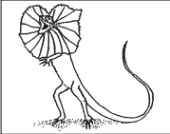
- 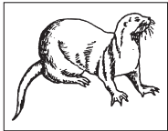
- 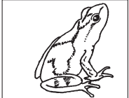
- 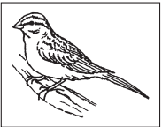

- A student is rolling a toy car down a ramp and determines that the toy car is not going fast enough.
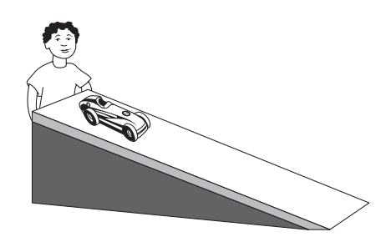
Which variable could the student test to make his car go faster?
- Pushing the car down the ramp.
- Increasing the height of the ramp.
- Getting a better car.
- Testing the wind speed.
- A group of students were doing an experiment with wind chimes and their experiment was setup as seen below.
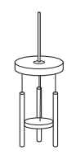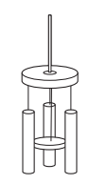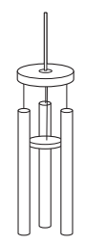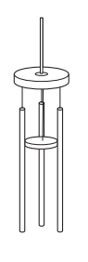
Rope
Base
Hammer
Sound Tube
Based on the images above, what may have been the variable to test?
- The size of the wind chime.
- The length of the rope.
- The size of the sound tube.
- The shape of the wind chime.

