Snowball Ring Toss

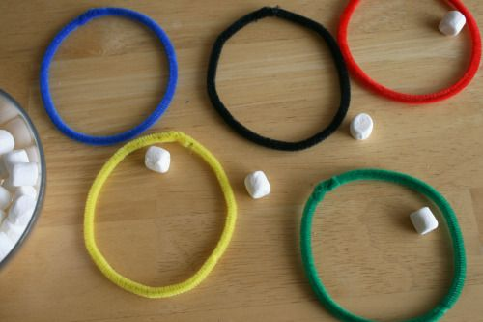
Materials:
- marshmallows, mini or regular
- Numeral Cards (values less than 10, vary according to grade level)
- 5 Olympic colored pipe cleaners, blue, black, red, yellow, and green
Loop your pipe cleaners into a circle and twist the two ends together. Place all 5 circles in the order of the Olympic rings.
Curriculum Outcomes –
N9 (addition) ****more specific for each grade level?***
Game:
Standing a few feet away from the rings, try tossing a marshmallow into each of the 5 rings.
Variation: Give a value to each Olympic ring. Have students add their totals after tossing their 5 marshmallows.
*For Grades 3-5, greater numbers can be used.

