Olympic Torch Shape Hunt

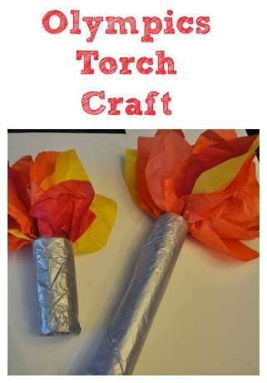
Materials:
- 2D Shapes
- 3D Objects
- Tissue paper
- Toilet Paper/Paper Towel Rolls
- Tin Foil

Curriculum Outcomes:

SS2: Sort 3-D objects and 2-D shapes using one attribute and explain the sorting rule.
SS2E: Determine the difference between two given pre-sorted sets of shapes and explain the rule

Before this lesson students will create a class Olympic torch:
Game:
Teacher will present a set of sorted objects: ie shapes with 3 sides and shapes with 4 sides. Students will have to determine the sorting rule. Once they have determined the rule they have to find shapes using the torch (teacher had printed out and placed around classroom) that would belong in each of the sorting groups.
Repeat with different sorting groups.

