Olympic Sport: Mogul Skiing
Material:
- coloured masking tape (painters tape works well)
- coloured Popsicle sticks
- black marker
- small baskets
- video of skier completing a mogul course
Outcomes:
KN1 Building Block A: Recite the number sequence forwards from 1
KN1 Building Block B: Recite the number sequence backwards from 10

G1N1 Building Block I: Skip count by 2s to 20 starting at 0
G1N1 Building Block J: Skip count by 5s to 100 starting at 0
G1N1 Building Block K: Skip count by 10s to 100 starting at 0

G2N1 Building Block G: Skip count by 10s to 100, given any number from 1 to 9 as a starting point
G2N1 Building Block J: Extend a given skip counting sequence by 2s forward starting from 1
Instructions:
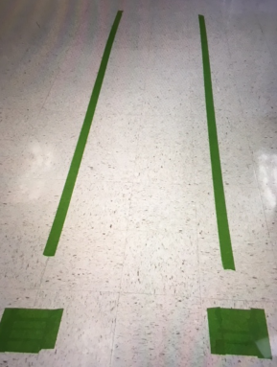
Mark off your course with two lines of coloured masking tape. Lengths depend on the grade level you are teaching.

Write a skip counting sequence on coloured Popsicle sticks.
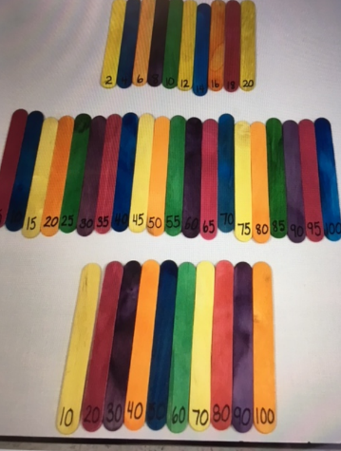
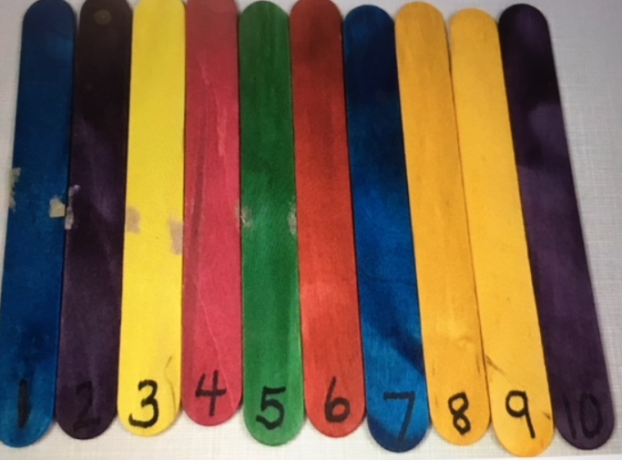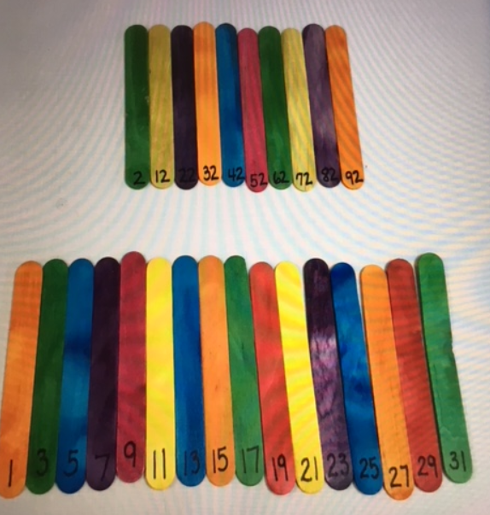
Show your students a video of a skier completing a mogul course. They will be able to see how the skiers “bump” down the course from side to side.

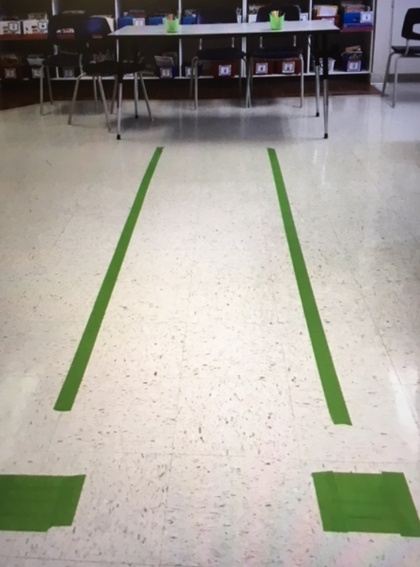
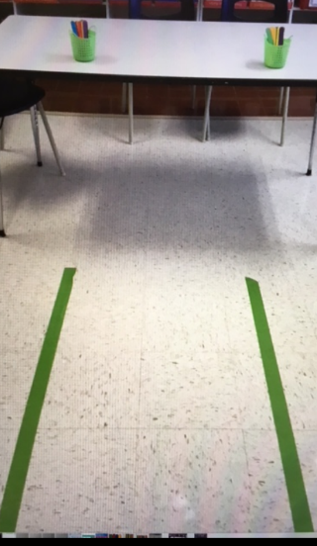
From the starting point (square) the students will ski the moguls by jumping on two feet from one side of the tape to the other. They can try to position their hands as though they are holding poles as well. Once they reach the end of the course (a table) the students will have to put a set of Popsicle sticks in the proper skip counting order. When they finish they will ski back to the start point.

