Olympic Sport: Biathlon
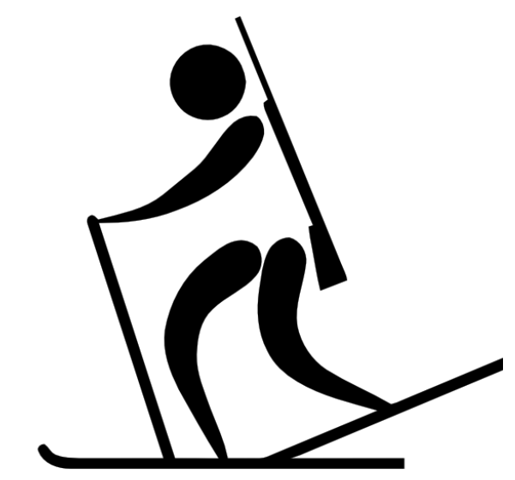
Materials: Part- Part Whole Charts
Recording sheet
Dry Erase Markers
Cardboard
Duct Tape
Wax paper
Hola Hoop (4)
Bean Bags (4)

Curriculum outcomes:
K: N4 F - Partition a quantity into two parts, identify the number in each part and tell whole without recounting
1: N4 C - Partition a quantity (11 to 20); tell amount in the whole
2: N9 E- Solve a given problem involving a missing addend and describe the strategy
Activity:
STEM- Provide materials (duct tape, cardboard, wax paper) to student to create one set of skis.
Numeracy -

