Olympic Sport: Biathlon
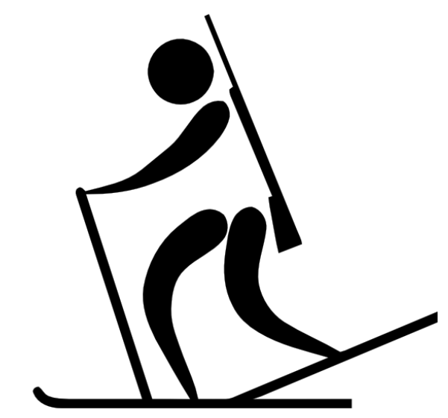
Materials:
- Part- Part Whole Card
- Recording sheets
- Dry Erase Markers
- Cardboard
- Duct Tape
- Wax paper
- Hola Hoop (4) Target
- Bean Bags (4)

Curriculum outcomes:
Kindergarten: N4 F - Partition a quantity into two parts, identify the number in each part and tell whole without recounting
Grade 1: N4 C - Partition a quantity (11 to 20); tell amount in the whole
Grade 2: N9 E- Solve a given problem involving a missing addend and describe the strategy

STEM- Provide materials (duct tape, cardboard, and wax paper) to student to create one set of skis for their team.

Game:
Numeracy – Grade K and Grade 1:
Divide class into four or five groups.
Provide groups with one part-part whole card with only the whole shown. Have them place the card face down at the starting line.
The first player will have one bean bag in their hand to start. They will turn over the card, race down to the end of the gym where the “whole” will be stationed to be partitioned into two parts. Student will physically divide the whole into two parts. When student finished dividing they need to throw their bean bag to hit a target to complete the biathlon part of the race. When the target is hit they can return to their team, record their two parts in the recording sheet and pass the bean bag to the next player. The next player will continue race partitioning the whole into two different parts, hitting their target, and returning to their team. This will continue until all players had a turn dividing the whole into two parts.

Numeracy Grade 2:
Same procedure as grades K and 1 except their part-part-whole cards would be missing an addend.
Teams would have four or five cards depending on number of students on each team. First student would turn over the first card, race down to the math tool station where they could use any tool (100 Rekenrek, 100 beads, open numberline, paper pencil ) to solve their missing addend (student could bring their card with them to help remember the other parts). When solving their questions they would throw their bean bag to hit the target and return to their team. The next player would turn over a new card and continue the procedure.
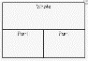
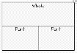
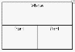
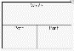
17 items
15 items
12 items
11 items
xxxx
xxxx
xxxx
xxxx

starting line Bean Bag Target

