Olympic Sport: Biathlon
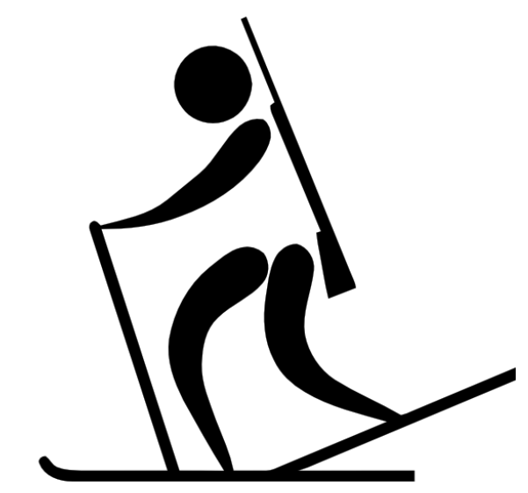
Materials: Part- Part Whole Charts
Recording sheet
Dry Erase Markers
Cardboard
Duct Tape
Wax paper
Hola Hoop (4)
Bean Bags (4)

Curriculum outcomes:
K: N4 F - Partition a quantity into two parts, identify the number in each part and tell whole without recounting
1: N4 C - Partition a quantity (11 to 20); tell amount in the whole
2: N9 E- Solve a given problem involving a missing addend and describe the strategy
Activity:
STEM- Provide materials (duct tape, cardboard, wax paper) to student to create one set of skis.
Numeracy – Grade K and Grade 1:
Divide class into four or five groups.
Provide students with one part-part whole card with the only the whole shown. Have them place the card face down at the starting line.
The first player will turn over the card, race down to the end of the gym where the “whole” will be waiting to be partitioned into two parts. Student will physically divide the whole into two parts. When student finished dividing they need to throw their bean bag to hit a target to complete the biathalon part of the race. When the target is hit they can return to their team, record their two parts in the recording sheet and pass the bean bag to the next player. The next player will continue race partitioning the whole into two different parts.

