Curling: Number Bond Plate Sweep

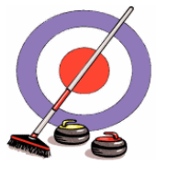
Materials:
- Paper Plates
- Brooms
- Number Cards
- Large Circle on Floor for target (flat)

Curriculum Outcomes:
Kindergarten: N4
Grade 1 & 2: N4 & N10

Preparation:
- Create 2 sets of large number cards 1 – 20 (one numeral per plate)
- On paper plates, write the numerals 0 – 20 (one numeral per plate)

Game:
- Have students form 2 lines behind the start line and give each person at the front of the line a broom.
- When instructed, each of them will turn over a numeral card at the start line and using their broom, they will find 2 or more numeral paper plates that “bond” to make their initial number and sweep them to the target.

Activity could be altered to meet various grade level outcomes: example; partners to 10, before and after, skip counting, multiplication, fact families, etc.

