Cross Country Plunger Challenge
You will need:
- 4 plungers
- 2 Scooter
- 1 bag of party hats
- 3 bags of small marshmallows
- 10 sets of numbers 1 to 20 (written on recipe cards)
- 10 big cones (gym)
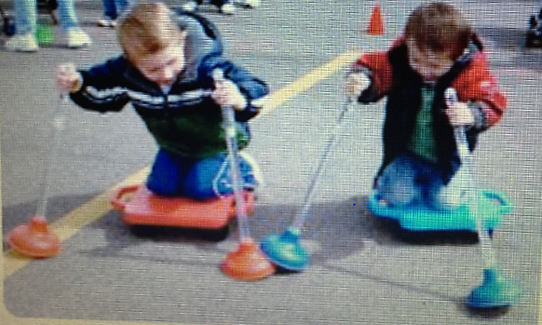
Curriculum outcome:
Kindergarten: N1E (number that comes after)
N1F (number that comes before)
*only need cards 1-10 for this grade level
Grade 1: N8A (name a number that is 1more, 2 more than a given number)
N8B (name a number that is 1 less, 2 less than a given number)
Grade 2: N1G 9 (10 more than a given number)
The team that arrives at the finish line with the most marshmallows wins the game.
Game:
- Divide the class in groups of 4.
- Team A vs Team B
- Both team start the race at the start line. Each student must sit on the scooter while holding a plunger in each hand.
- Each student must also place a party hat around their neck as they will be using it to collect their marshmallows.

Remember, you are cross-country skiing to the finish line.

- At go, each student tries to go as fast as they can to the first cone.
- A student will be at each cone to show a number and ask a question.

Example (With grade 1 students)

Show card 8 and ask what number is 1 more than 8? If correct, the student places a marshmallow in the party hat. If incorrect, they continue to the next cone where, another student asks another question.

- If both students arrive at a cone at the same time, the student with the correct answer gets the marshmallow.
- Continue going from cone to cone until you get to the finish line.
- Turn around and come back as quickly as possible to the startup line on your scooter with both plungers in your hands.
- Then you pass on the scooter and two plungers to the next person on your team.
- You continue until all four team members have gone.
- Finally, the team counts how many marshmallows they have received.

Other groups of 4 compete until all the class has played. The team with the most marshmallows wins the game.
