Below is a graph of atmospheric pressure with time from December 15, 2014. Use the graph to answer the questions. The dashed line is the line that best fits the data.

- As time increases from 0:00 hours to 23:00 hours how does atmospheric pressure change:
  - Increase linearly
  - Increase non-linearly
  - Decrease linearly
  - Decrease non-linearly

- Estimate the atmospheric pressure at 6:00 hours.

- Estimate at what time of the day was the atmospheric pressure 101.5 kPa.

- Estimate the atmospheric pressure at 2:00 hours.

- Estimate the time when the atmospheric pressure was 101.9 kPa.

Use the graph of Precipitation on the Ground with Day to answer the following questions (assume data was collected at 11 pm daily):
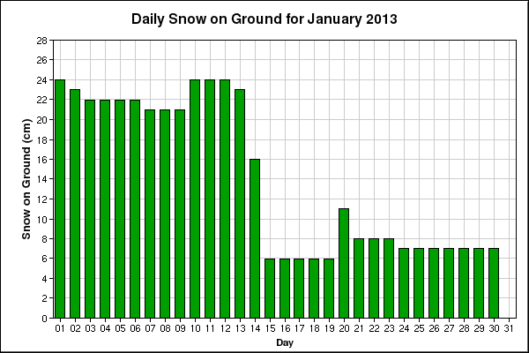
- On what day(s) can you say it definitely snowed?

- On what day(s) was the day temperature most likely above zero?

- What day was the coldest of the month?

- List the most likely three warmest days in descending order.

- Could it have rained during that month? If so, which day(s) and what data supports your claim?

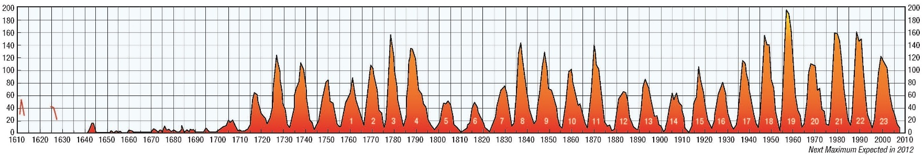
Below is a graph of how many sunspots have been observed on the Sun since 1610. Years where the graph peaks is called solar maximums (usually lots of auroras and solar flares); years where the graph dips are called solar minimums (low solar flare activity)
- Some would say that the Sun didn’t start getting a lot of sunspots until 1717 – would you agree or disagree with that statement? Briefly explain your reasoning.

- What are the next two solar maximums after 2012?

- What were the two previous solar minimums before 1690?

