Grade 6 Science – Sample Questions
- Students conducted an investigation by placing thermometers in various locations in the classroom to see if there is a difference in temperature. Their thermometers are pictured below.
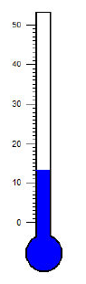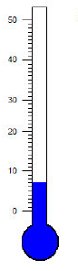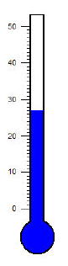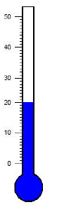
Teacher’s Closet Window Bookshelf
desk
What can you conclude from the experiment above?
- The bookshelf is near the closet.
- The teacher’s desk is near the window.
- The closet is near the teacher’s desk.
- The window is near the closet.

- A student tested three brands of batteries to learn which would last the longest in a flashlight. The student graphed their findings below.
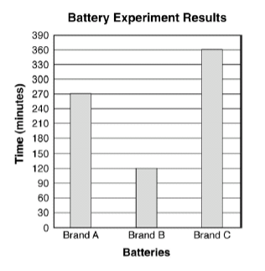
Which of these is an accurate conclusion that can be made for the experiment?
- Brand C lasted three times as long as Brand B.
- Brand C lasted twice as long as Brand A.
- The light was twice as bright with Brand A then brand B.
- The light shined three times farther with Brand C then Brand B.

- The picture below shows the equipment used in an experiment to determine the effect of ramp height on the total distance a toy car travels.
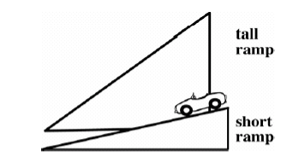
The students performed the following steps:
- Place the car at the top of the shorter ramp
- Let the car go until it stops
- Measure the distance the car travels
- Record the distance in a chart
Which step should be completed next?
- Place the car at the top of the taller ramp.
- Decide which ramp will make the car go farther.
- Replace the surface on the ramp.
- Change the wheels on the car.

- The graph below shows the height of three different students over the course of five years.
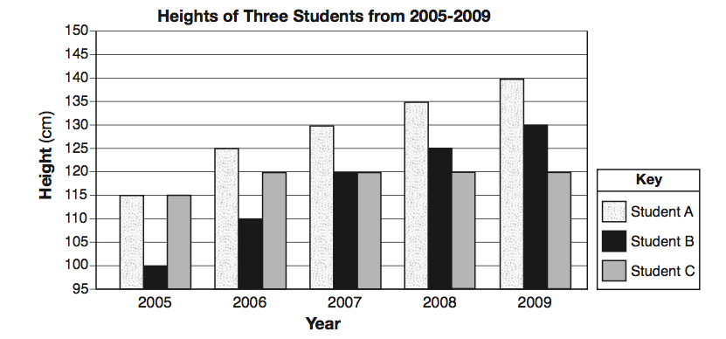
- Using the graph above, describe the growth pattern of student B.

- Write a statement that can explain the height measurements for 2007.

