Grade 6 Science – Sample Questions
- The image below shows a food chain near a swamp. According to the image below, the heron eats the frog, the frog eats the grasshopper, the grasshopper eats the grass and the grass uses the energy from the sun to grow.
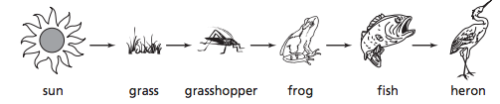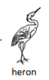
sun grass grasshopper frog heron
What would most likely happen if the frog population disappeared?
- The grasshopper population would increase.
- The fish population would increase.
- The grass would grow taller.
- The herons would grow bigger.
- A student is conducting an investigation and needs to measure 20 mL of water.
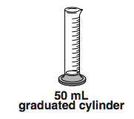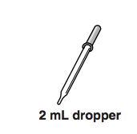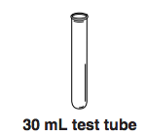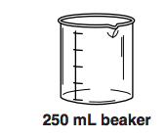
250 ml beaker 30 ml test tube 2 ml dropper 50 ml graduated
cylinder
Which measuring tool would be the most accurate?
- Beaker.
- Test tube.
- Eye dropper.
- Graduated cylinder.

- Three groups performed an experiment in their class and received the following results.
Group A | Group B | Group C
100 ml of water | 100 ml of water | 100 ml of water
10 g of sugar | 13 g of sugar | 11 g of sugar
5 g of yeast | 7 g of yeast | 2 g of yeast
What is the controlled variable in this experiment?
- The amount of water.
- The materials used.
- The amount of sugar.
- The amount of yeast.

- Two students wanted to see who could throw a baseball the farthest. The following chart shows their results. .
Distance the baseball travelled
 | Trial 1 | Trial 2 | Trial 3
Student 1 | 23m | 18m | 20m
Student 2 | 16m | 21m | 20m

- Create and label a double bar graph that shows the students’ results.
- Based on the results, who can throw the ball the farthest? Explain your reasoning.

