Grade 4 Science – Sample Questions
- We started with two identical candles. Candle B was lit and burned for an hour. After the hour, the candles were measured, as shown in the diagram below.
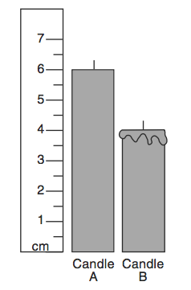
Candle A Candle B
How tall will candle A be after burning for a total of 1 ½ hours?
- 3 cm
- 1 cm
- 5 cm
- 2 cm
- A grade 4 class did a survey of eye color for all of their grade 4 students at their school. Their data is listed below:
 | Blue | Brown | Green
Mr. Leblanc Class | 9 | 7 | 1
Mrs. Hatter Class | 2 | 10 | 4
What does the chart above say about eye color at this school?
- Green is the least common eye color in both grade 4 classes.
- Blue eyes are more common in boys than in girls in the fourth grade.
- Brown is the most common eye color in each grade 4 class.
- Brown is the most common eye color of grade 4 students.

- The following graph shows the lifespan of different animals. A class has decided to get 3 rabbits as class pets.
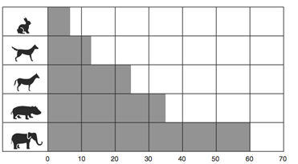
Average life span
Rabbit
Dog
Horse
Hippopotamus
Elephant
How long are the 3 rabbits expected to live?
- 24 years
- 16 years
- 8 years
- 3 years

- Students were asked to measure the length of 5 different objects in their classroom. The results are found the table below.
Object | Length (cm)
table | 130 cm
desk | 54 cm
book | 32 cm
shelf | 64 cm
SMART board | 140 cm
- Based on the results, construct a bar graph.
- Write a statement that describes the difference between the length of a book and the length of the shelf.

