Grade 3:
The four bean seeds in the diagram below were planted on different days. Each seed was planted in the same kind of soil and pot. The seeds were given the same amounts of sunlight and water each day. The diagram shows all four puts on the same day. The pots are labeled A, B, C, and D.
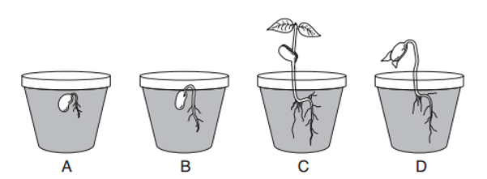
Based on the growth and development of the four bean seeds, which one most likely was planted before the other three?
______

A student planted two bean seeds in two identical pots containing the same type of soil. He placed one pot in a closet and the other near a sunny window. Each day, he poured 15 milliliters of water into each pot.

Which factor was different for the two pots?

A amount of water
B amount of light
C type of soil
D type of seed
________

The hardness, odor, and taste of an object can all be

A measured with a metric ruler
B measured with a spring smile
C observed with the senses
D observed with a hand lens
_______________

A student reaches into a bag of objects. Which property of the objects can be observed by using only the sense of touch?

A color B odor C taste D texture
A student classified the following materials. What label did the student most likely place on boxes A and B?
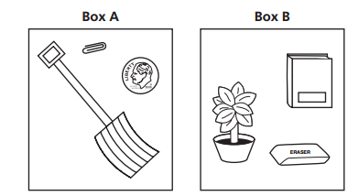
A metal and nonmetal
B living and nonliving
C land based and water based
D heavy and light
_________
Grade 4

How is the snail’s shell like the porcupine’s quills?
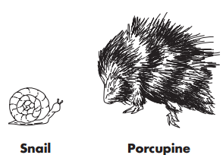
A) They are both used for digestion.
B) They are both used for protection.
C) They are both used for food gathering.
D) They are both used for breathing.
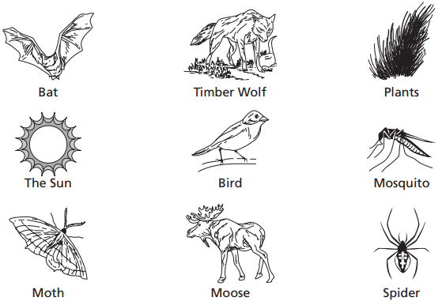

Part A: Using the chart below, classify all the items shown above into two different groups, according to a feature that one group has and the other group does not. Write the feature on the line at the top of each column. Write or draw the items in the boxes.
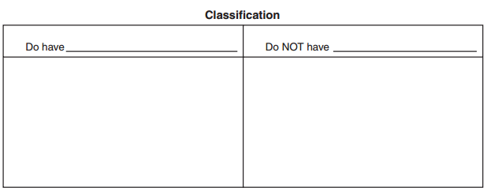

Part B: Build your own food chain or food web that includes at least four items from the previous page. Be sure to label all parts of your food chain or web
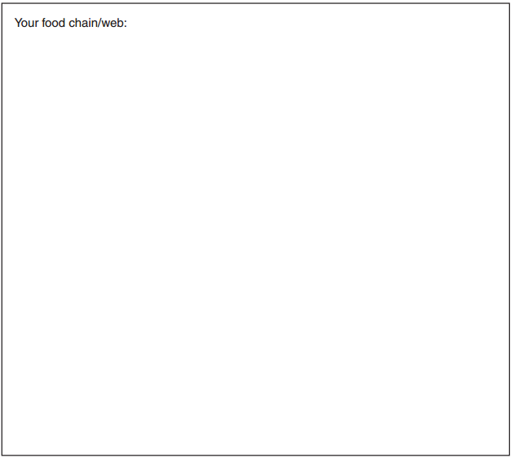
_______________
The picture below shows four different rock layers in a hillside. What is the best evidence that one of these layers of rock was formed under an ocean?
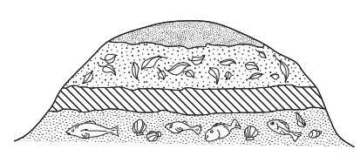
A the thickness of the layer
B the type of fossils in the layer
C the number of caves in the layer
D the height above sea level of the layer
Janet wants to buy the wind chime that will make a sound with the lowest pitch. Which wind chime should she buy?
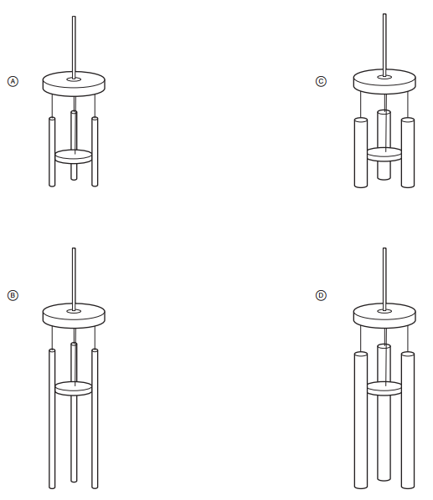

___________
Grade 5

A student removes an ice cube tray from the freezer and places it on a table. The ice cubes are solid and cold. The student forgets to put the ice cube tray back into the freezer. The next day, the ice cubes should be

A liquid and warmer
B solid and warmer
C liquid and colder
D solid and colder
__________

The data table below shows some average monthly air temperatures for a city in New Brunswick. Tl1e average air temperature for the month of April is not shown.
Month | Average Temperature (°C)
January | -9
February | -6
March | +3
May | +14
June | +18

Based on the data, what would the average air temperature probably have been in April?
A -15 °C B 0 °C C +9 °C D +25 °C
___________

During which part of this cycle does it snow?
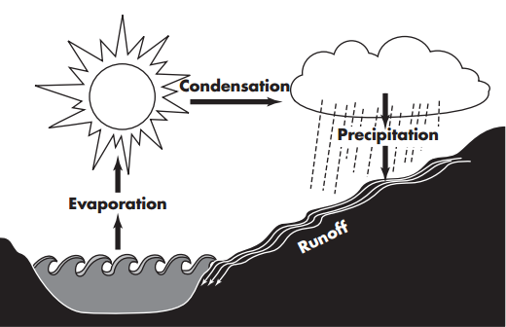
A Evaporation B Condensation C Precipitation D Runoff

Several boxes need to be moved. Which one needs the greatest amount of push to start moving?
A the darkest box
B the heaviest box
C the brightest box
D the smoothest box

Grade 6

Two tanks with ﬁsh are shown below. Parent ﬁsh are in tank 1. The ﬁsh in tank 2 are labeled A, B, C, and D.
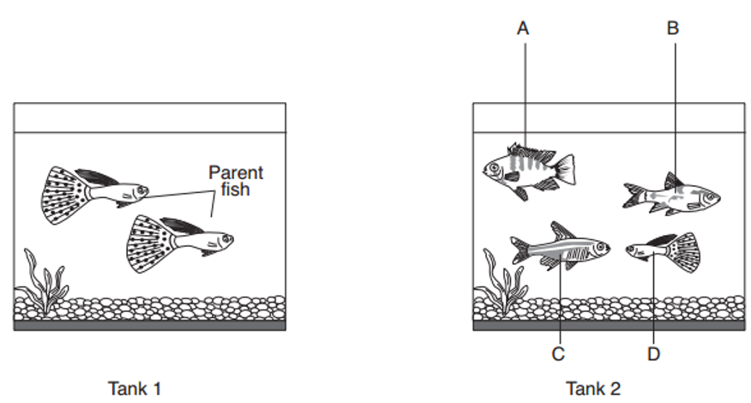
Which ﬁsh in tank 2 is most likely the offspring of the two parent fish in tank 1?
__________

The diagram below represents four organisms.
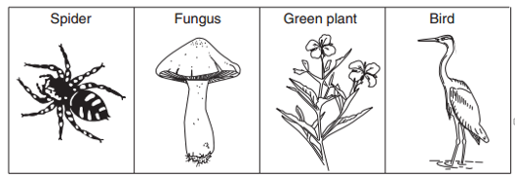
(Not drawn to scale)

How many of the organisms represented are multicellular?

(A) one
(B) two
(C) three
(D) four

Letters A, B, C and D in the diagram below represent four positions of the Moon in its orbit around Earth.
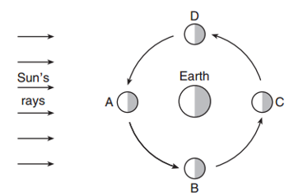
(Not drawn to scale)

At which Moon position would a person on Earth see the entire lighted half of the Moon (Full—Moon phase)?
(A) A (B) B (C) C (D) D
______________________

The diagram below represents a species of beetle (ladybug) with two different colours labeled A and B. These beetles live on trees and are eaten by birds. The percentage of each body color in the population of this species is indicated. The habitat of this beetle population is a group of trees with light-colored bark.
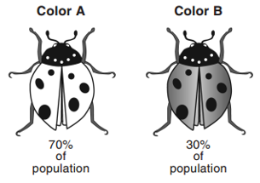
Based on the information provided, explain why the beetle population in this habitat contains a higher percentage of beetles with body color A.

_____________________________________________________________________________

_____________________________________________________________________________

_____________________________________________________________________________

Base your answers to the next two questions on the drawings of bird feet and the dichotomous key below.
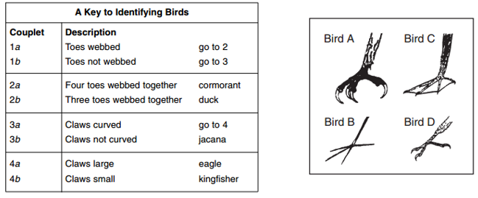
Bird B is correctly identified as

(A) a cormorant (C) an eagle
(B) a duck (D) a jacana
_______________

What is a common feature of both the eagle and the kingﬁsher?

(A) claws large (C) three toes webbed together
(B) claws curved (D) four toes webbed together
____________________

While in space, astronauts must meet their basic needs. In the table below, identify a basic need and how it is met in space.

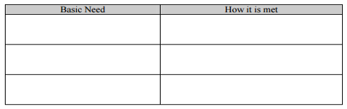

What is meant by space spin-offs? Give three examples of space spin-offs.
_____________________________________________________________________________

_____________________________________________________________________________

_____________________________________________________________________________

How would you be able to play soccer in microgravity? Describe changes in any of the rules or equipment
_____________________________________________________________________________

_____________________________________________________________________________

_____________________________________________________________________________

Grade 7
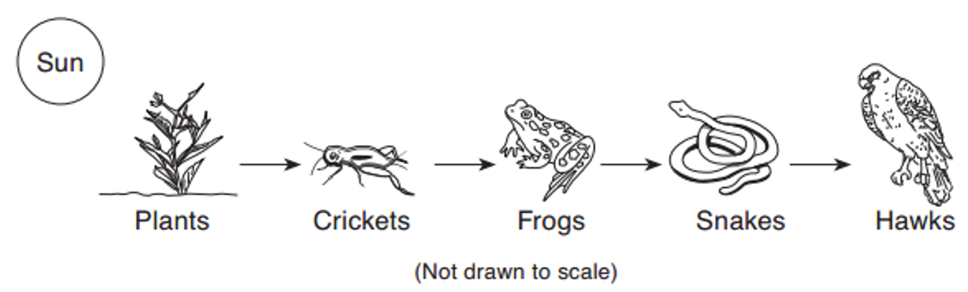
If the number of frogs suddenly increases, which population will most likely decrease ﬁrst?
A hawks B snakes C crickets D plants
__________

Identify one producer labeled in this food web.
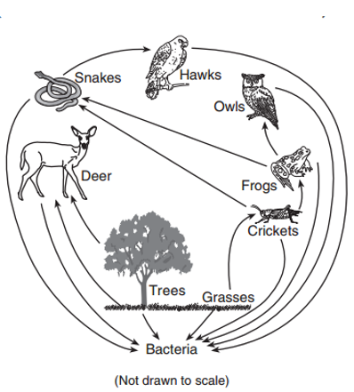

Which graph shows what most likely would happen to the population of a certain animal if a new predator were introduced at time A?
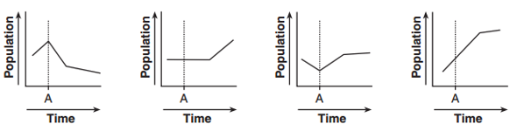
A B C D
__________________________

Base your answers to the next two questions on the partial food web below
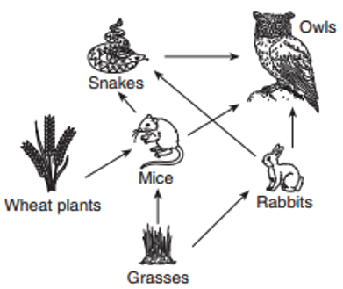

These organisms can be classiﬁed according to the way they obtain energy Complete the chart below by identifying one example of each type of organism labelled in this food web.
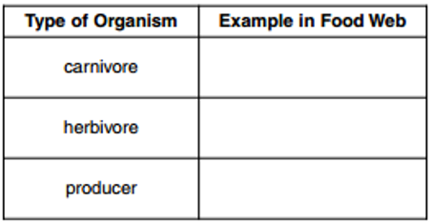

Explain why the population of rabbits might decrease if the population of mice decreased.

_____________________________________________________________________________

_____________________________________________________________________________

_____________________________________________________________________________

A glacier in Alaska has melted back a distance of 100 kilometers over the last 200 years. Four stages in this process are shown in diagrams A. B. C, and D below.
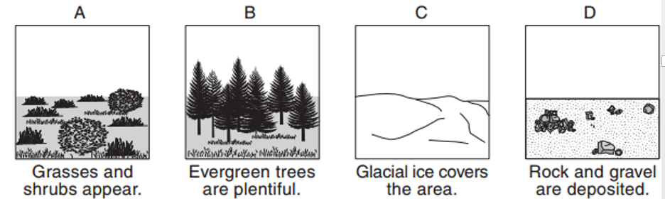

In which order should the diagrams he placed to represent the ecological succession that has taken place in the area?

(A) C->D->A->B (B) D->C->B->A (C) C->D->B->A (D) D->C->A->B
_________________

A Grade 7 science student tracks soil into her house after being outside. The soil is ﬁne with brown, rock-like particles in it. According to the classiﬁcation chart shown above, where had the student most likely been before entering her house?
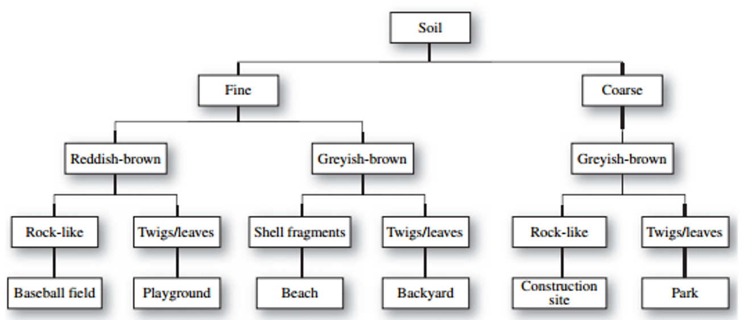

A. Beach
B. Playground
C. Baseball ﬁeld
D. Construction site
_________

Grade 8
The graph below shows the solubility of three substances in 100 grams of water at various temperatures.
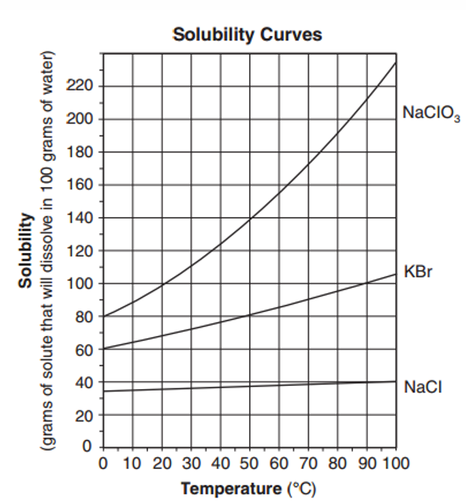

How many grams of KBr will dissolve in 100 grams of water at 60°C? _________

The data table below shows three properties of six different-sized samples of quartz sand. One property of the samples is labeled X. A student used the data for mass and property X to calculate the density of each sand sample.
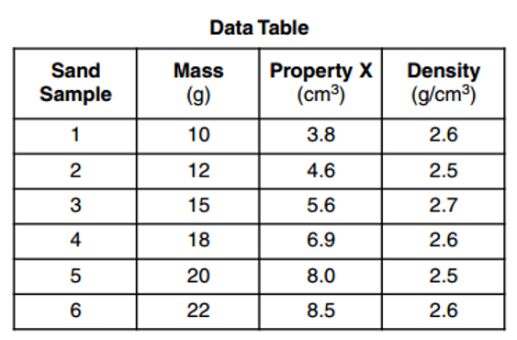

What property of the samples is represented by X? __________________

All of the quartz samples should have had the same density. State one error the student may have made during the experiment.
________________________________________________________________________

________________________________________________________________________

Base your answers to the next two questions on the diagram below and on your knowledge of science. The diagram represents an enlarged view of a plant cell. Several cell structures have been labeled.

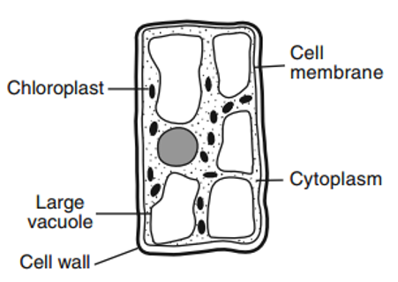

Identity two labeled structures that identify this cell as a plant cell rather than an animal cell.

(1)______________________________

(2)______________________________
Identify one other structure that could he found in this plant cell that is not labeled in the diagram.

______________________________
Base your answers to the next two questions on the diagram below and on your knowledge of science. The diagram represents a human organ system. The arrows show the directions of blood flow. Letters A and B represent locations in this system.

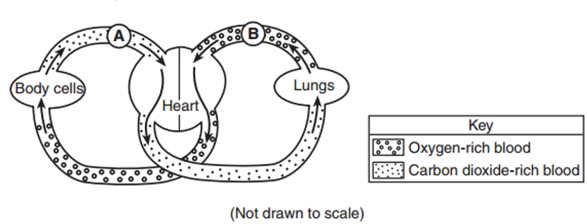
Identify the organ system responsible for the movement of blood shown in the diagram. _______________system

State one reason why blood at location B contains more oxygen than blood at location A.
_____________________________________________________________________

_____________________________________________________________________

The diagram below shows a rock being placed in a graduated cylinder containing water.

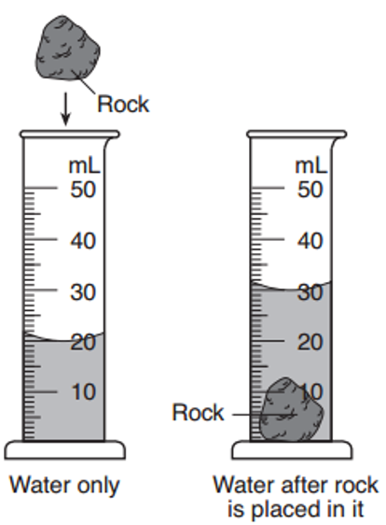
What is the volume of the rock? Note: 1 mL = 1 cm³ _____________________
A student was studying a prepared slide of human cheek cells under a compound microscope. The diagram represents what the student observed on the slide at a magnification of 100x

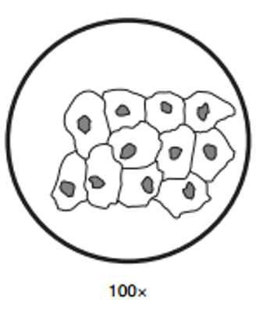

Identify the shaded structure in each cell in the diagram ________________

Draw what the student would see if the cells were views under 400x magnification with the microscope. Your drawing should be contained within the circle below.

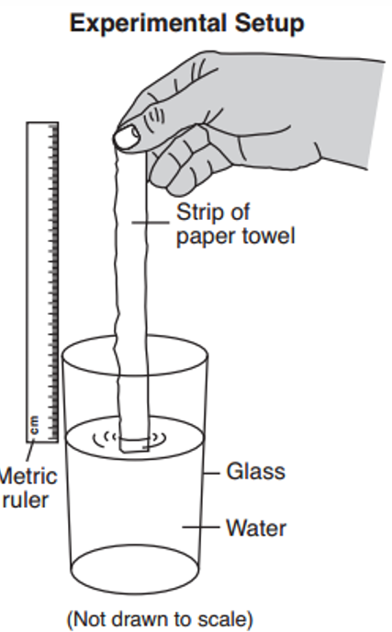
An experiment was done to study the amount of capillary action that occurs in a certain type of paper towel. Capillary action is the upward movement of liquid through tiny spaces. A strip of paper towel was held with one end in a glass of water. The water height in the towel was recorded every live seconds. Three trials were done using the same type of towel. The diagram shows the experimental setup and the data table shows the results of the experiment.

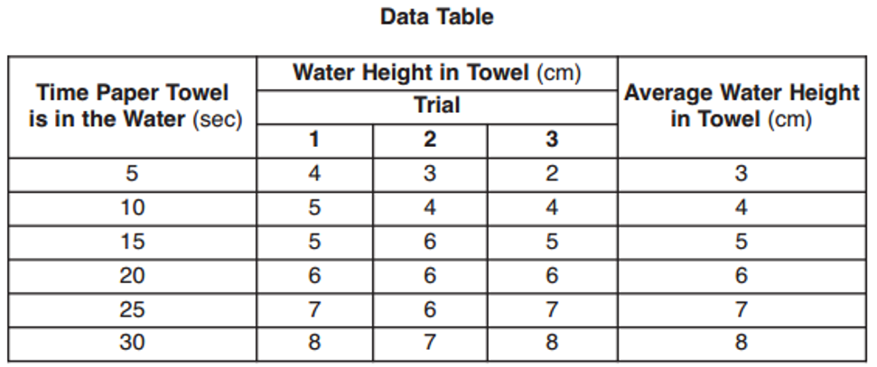
Identity one factor that should remain constant in all three trials of this experiment.

__________________________________

State one conclusion that can be drawn from the results of this experiment.

____________________________________________________________________________

____________________________________________________________________________

____________________________________________________________________________

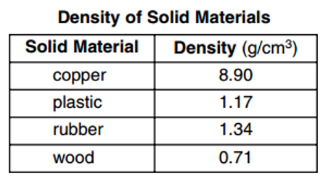

Indicate where each of the four solid materials would be located by writing the name of each solid material in the space provided.

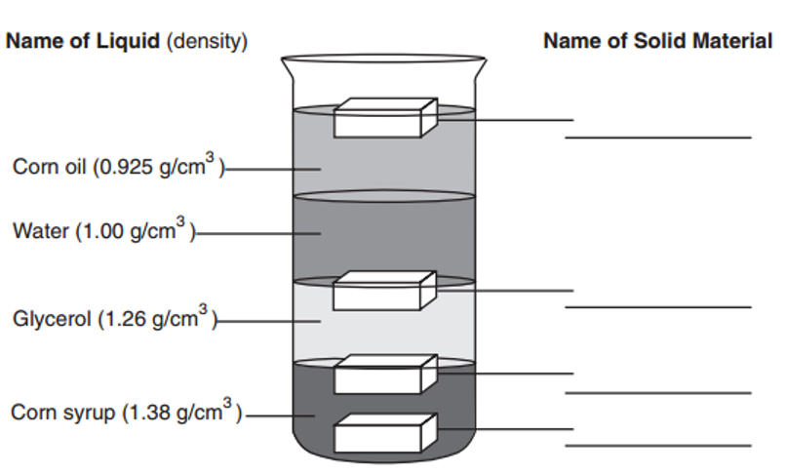

Grade 9
A student added an equal amount of sugar to three containers. Each container had 400 mL of water at different temperatures. His observations are shown in the diagram below.
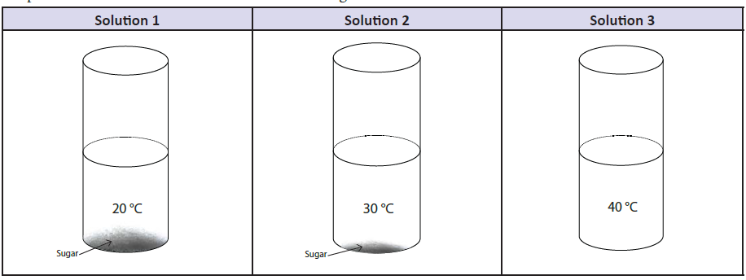
What conclusion could the student draw about his experiment?

___________________________________________________________________________

___________________________________________________________________________

___________________________________________________________________________

List three pieces of equipment that the student should use to get precise results in the experiment above.
___________________________

___________________________

___________________________

The student draws a hypothesis. If the temperature is the same, then, as the volume of water increases, the amount of sugar that can be dissolved increases. Which graph below shows the student’s hypothesis?
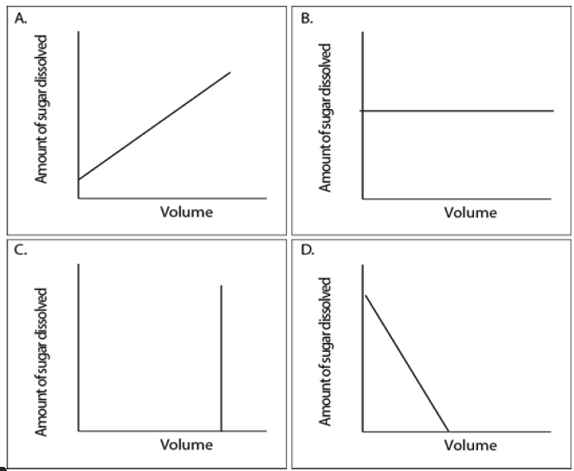

Grade 10
Scientists have observed that the amount of carbon dioxide (CO2) in the atmosphere has been increasing. Data on the change in average global temperature and the amount of CO2 in the atmosphere from 1880 to 2008 are shown in the graph below.
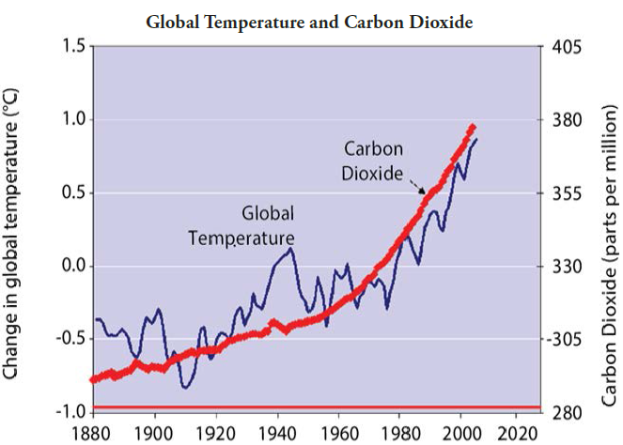
Describe the relationship between global temperature and CO2 shown in the graph.
_____________________________________________________________________________

_____________________________________________________________________________

If the trend on the graph from 1980 to 2005 continues, predict how much CO2 will be in the atmosphere in 2020.
A. 1.4 parts per million B. 1.7 parts per million
C. 400 parts per million D. 415 parts per million
____________
Four scientists recorded the following data. Which scientist is the most reliable?
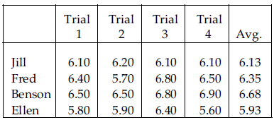

A Jill B Fred C Benson D Ellen

Grade 11/12

The sexually-transmitted disease gonorrhea is becoming difficult to treat because the bacteria are evolving resistance to antibiotics. For example, in Hawaii between 1997 and 1999 resistance to fluoroquinolones increased from 1.4 percent to 9.5 percent. Scientists attribute this to natural selection. What does natural selection mean in this context?
- The germs have learned to avoid that particular class of antibiotic.
- The antibiotic has changed the genetic structure of the germs allowing them to become antibiotic-resistant.
- The germs changed their genetic code in order to avoid problems with the antibiotic.
- The antibiotic created an environment in which germs harboring antibiotic-resistant genes could flourish.
- The mutation rate for antibiotic-resistance increased during the time period.
_______________________
You are involved in a marine habitat conservation project and find that that crab predation by herring gulls in the intertidal zone is 20x greater on sites lacking concealment cover of fronds of rockweed. How might you best characterize the ecological status of rockweed in this situation?
A. Keystone species B. Umbrella species C. Flagship species
D. Endangered species E. Foundation species.
_______________________
Domoic acid, isolated from a diatom, has been found experimentally to bind to hippocampal glutamate receptors. If a person were to accidently consume shellfish contaminated with this organism, what effect might be expected?
- Blindness. B. Deafness. C. Amnesia. D. Aphasia. E. Rigidity.
______
Lannie and Phil both have healthy parents but each has a sister with autosomal recessive cystic fibrosis. If Lannie and Phil have a child, what is the probability that it will be born with cystic fibrosis?
- 0 B. ½ C. 1/3 D. 1/9 E. 1/36
_______________________
A biologist studied the environmental impact of an herbicide on squirrel reproduction. He selected two small islands with similar vegetation and similar-sized squirrel populations (about 200 squirrels) with equal reproductive rates. One island, selected at random, was sprayed with herbicide, and the other was used as a control. Squirrel reproduction rates were measured on both islands before and after the treatment. What is the greatest flaw in this investigation?
- Poor outcome measure. B. Lack of controls C. Lack of replication. D. Lack of randomization.
A man diagnosed with Parkinson’s suspected that pollution at his workplace (a mill) may be to blame. Which of the following statements would lend greatest support to his suspicion?
- A survey of workers at the mill reveals many cases of illness.
- A survey of workers at the mill and at other similar mills reveals many cases of illness.
- The incidence of illness is higher among the mill workers than among age-matched workers in non-polluted workplaces.
- The national average incidence of Parkinson’s is lower than that among workers at the mill.
_______________________
A coach is concerned about the electrolyte balance of an athlete performing in a warm climate. She estimates that ambient temperature and humidity conditions will result in a perspiration loss of about two liters of NaCl solution from the athlete during an Olympic event. The athlete weighs 50 kg and begins the event with a plasma sodium concentration of 140 mmol/L. Assume average sodium sweat-loss of 70 mmol/L, assume no water intake, and ignore kidney function. Approximately what would be the plasma sodium concentration at the end of the event?
- 130 mmol/L B. 135 mmol/L C. 140 mmol/L D. 145 mmol/L E. 150 mmol/L
_______________________
George claimed that a tropical animal protein supplied by a local naturopath was effective in lowering blood pressure, and George was planning to invest in the product. As evidence of his claim, George, who had hypertension, said that he felt much better after the treatment and had much more energy. In comparison to a credible scientific investigation, how is George's inference flawed?
- Lack of an appropriate outcome measure.
- Lack of appropriate controls and lack of an appropriate outcome measure.
- Lack of randomization, lack of replication, and lack of an appropriate outcome measure.
- Lack of replication and lack of appropriate controls.
- Lack of appropriate outcome measure, replication, randomization, and controls.
_______________________
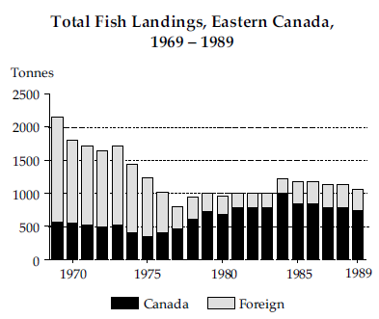

In 1977 Canada was given control of a fishing zone extending 320 km around the coastline. This meant that foreign vessels could fish inside this zone only with Canada’s permission.
From the graph, what is the best inference about the effect of this extension of Canada’s control?

A Total landings have continued to decline since the extension of control.

B Foreign fishing vessels are overfishing the area.

C Canada’s share of the total catch has increased substantially since extension of control.

D If we keep fishing at current levels the fish stock will be destroyed.
_______________________
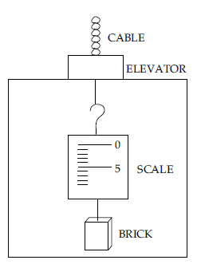
A brick is hanging from a spring scale in an elevator. The scale will show the lowest reading when the

A elevator is stationary.
B elevator is accelerating upward.
C elevator is moving downward at a constant speed.
D cable is severed and the elevator is freefalling.

