Program your FriendBot

Create an algorithm for your FriendBot get across the room.

- Your FriendBot isn’t able to make decisions or do anything until you provide some commands.
- Your FriendBot can follow simple commands like these:
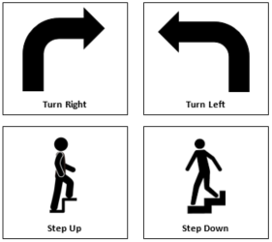
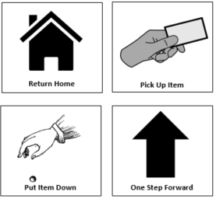

- Your job is to create an algorithm that will get your FriendBot to cross the room, pick up an item, and bring it to you.
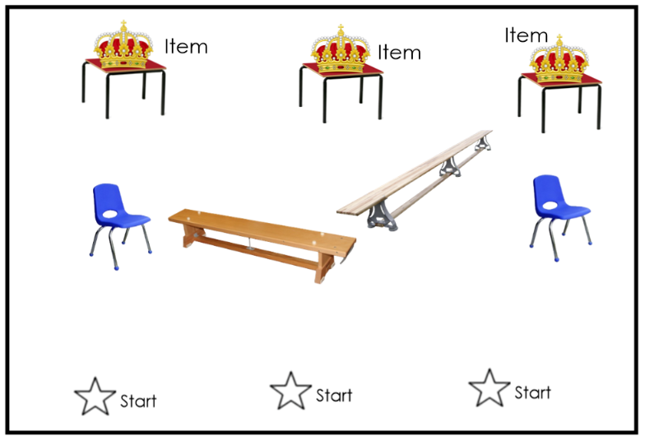

- You can program your FriendBot by placing command cards in an ordered stack. Your FriendBot will follow the commands one at a time. If your FriendBot gets stuck or can’t make it to the item, you need to try to fix your algorithm and get your FriendBot to start again.
- The last two commands of the program should be the Return Home command and then the Put Item Down.
**If the FriendBot has to walk a long distance, write the number of steps to take on a single “One Step Forward” command card. Use a dry erase marker if the card is laminated.

