**Pick Up Item**

**Return Home**

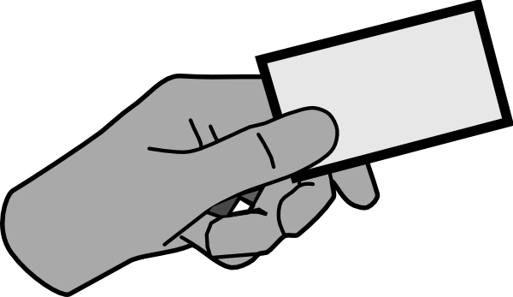

**One Step Forward**

**Put Item Down**

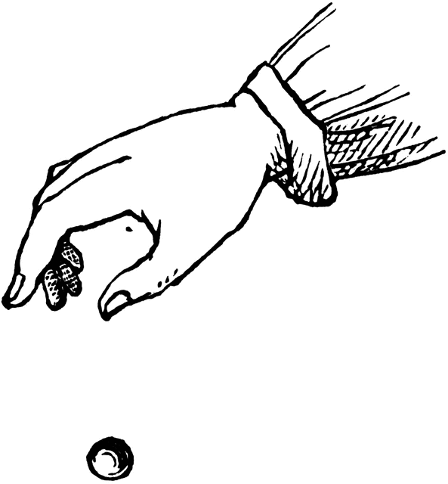

**One Step Forward**

**One Step Forward**

**One Step Forward**

**One Step Forward**

**One Step Forward**

**One Step Forward**

**One Step Backward**

**One Step Backward**

**Turn Right**

**Turn Left**

**Turn Right**

**Turn Left**

**Step Down**



**Step Up**

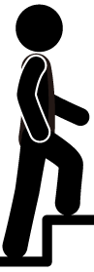

**Step Down**



**Step Up**



**Turn Left**

**Turn Right**

**One Step Backward**

**One Step Forward**