Botley: Place Value
SCO: N7: Illustrate, concretely, and pictorially, the meaning of place value for numerals to 100.

Description:
Students will code Botley to travel to the appropriate value of an indicated place within a given numeral.

Materials:
Botley robot and controller, number line mat, place value cards (printable)

Prep:
Set up the number line mat with appropriate place value number cards (either in order or not).

Activity:
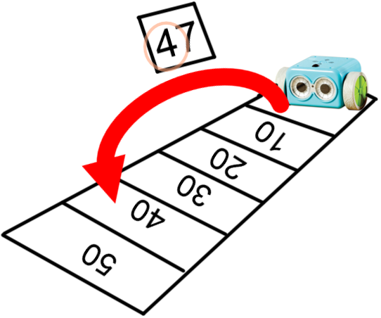
Students will draw a number card from the pile. Students will match the given place on the number (ones or tens) card with the corresponding value on the mat. The student will then program Botley to travel along the mat to the answer, turn around, and travel back.

0 | 1
2 | 3
4 | 5
6 | 7
8 | 9
10 | 20
30 | 40
50 | 60

70 | 80
90 | 0
67 | 14
29 | 88
46 | 7
31 | 70
52 | 97
62 | 25

