Name:________________

Relating Addition and Subtraction

Instructions: Have students solve each question below. When all three questioned are solved ask: “What do you notice about the numbers in each question?”

- There are eight birds in a tree. Five more birds came. How many birds are there in the tree altogether?
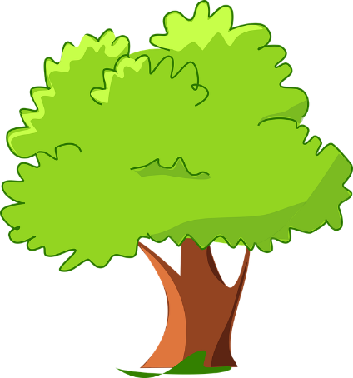

- Thirteen cars are in the parking lot. Five cars were blue and the rest were black. How many cars are black?
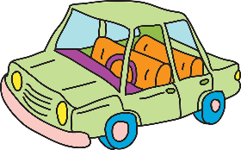

- There are five apples in a bag. Some more apples were put in the same bag. Now there are 13 apples in the bag. How many apples were added to the bag?
