I have the first card

Who has…

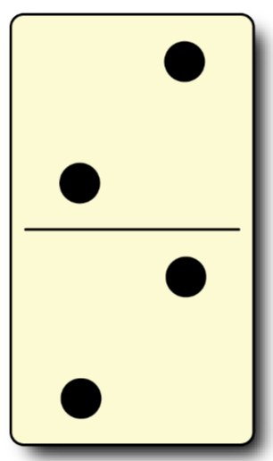

I have



Who has…

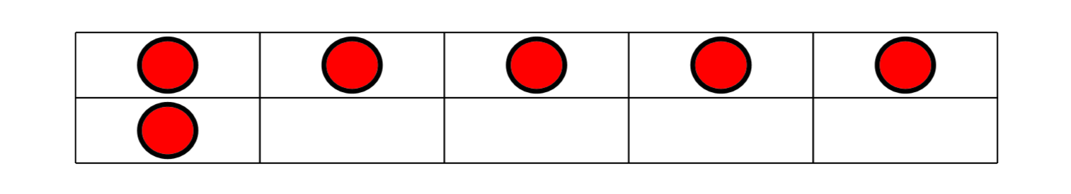

I have





Who has…

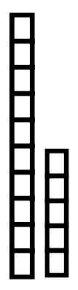

I have

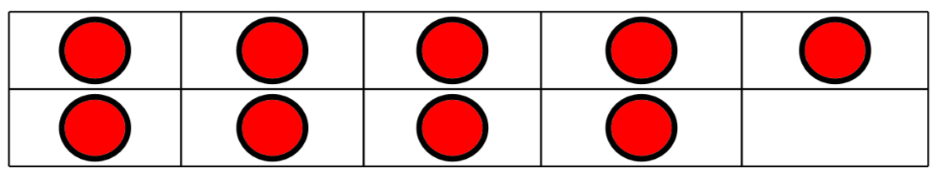

Who has…



I have

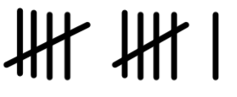

Who has…



I have



Who has…



I have

Nineteen

Who has…

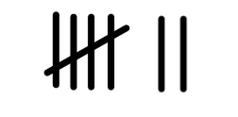

I have



Who has…

Nineteen

I have

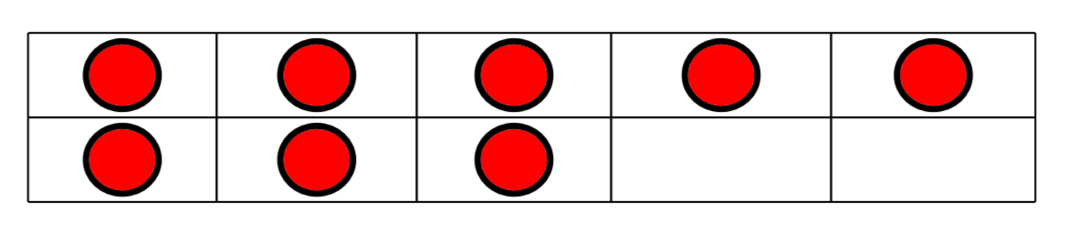

Who has…



I have



Who has…

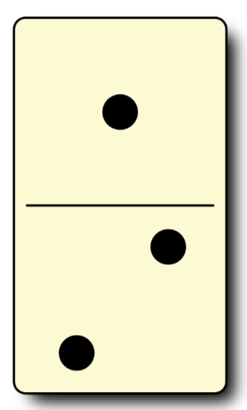

I have



Who has…

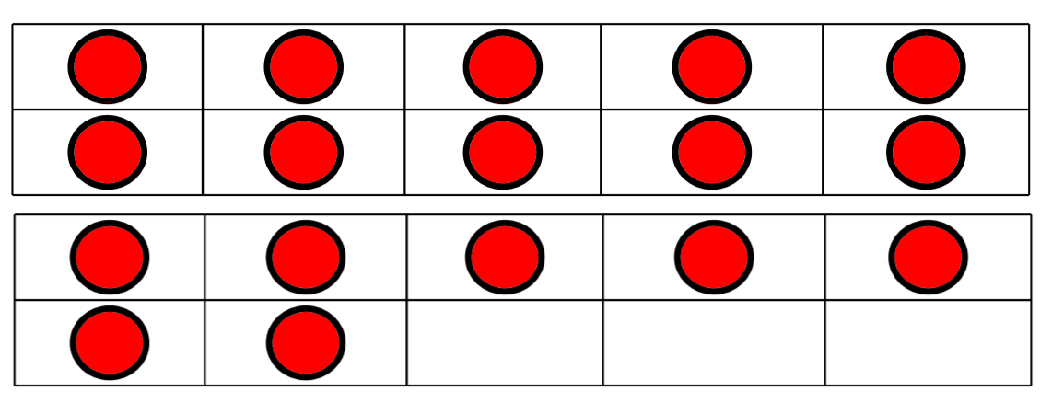

I have



Who has…

Eight

I have

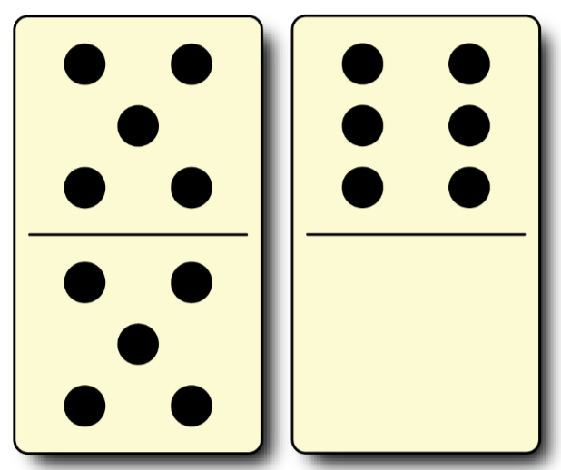

Who has…

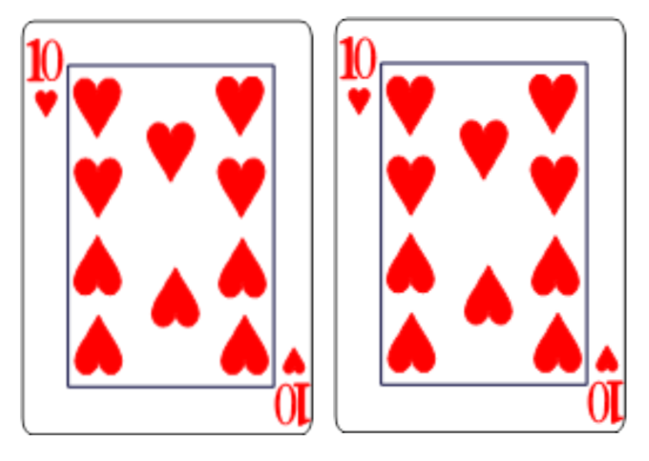

I have

Who has…



I have

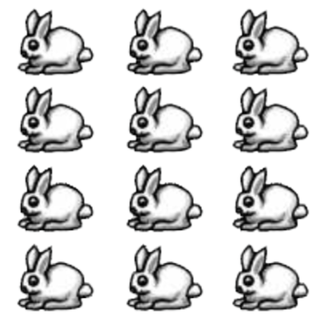

Who has…



I have



Who has…



I have



Who has…

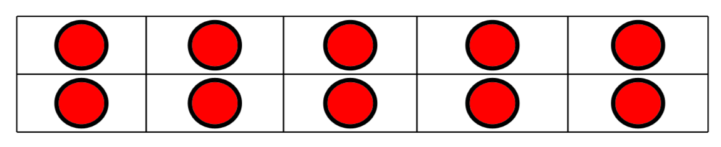

I have



Who has…



I have

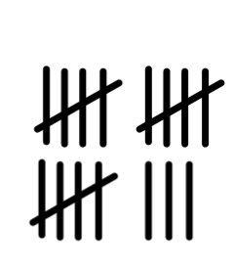

The End

I have



Who has…

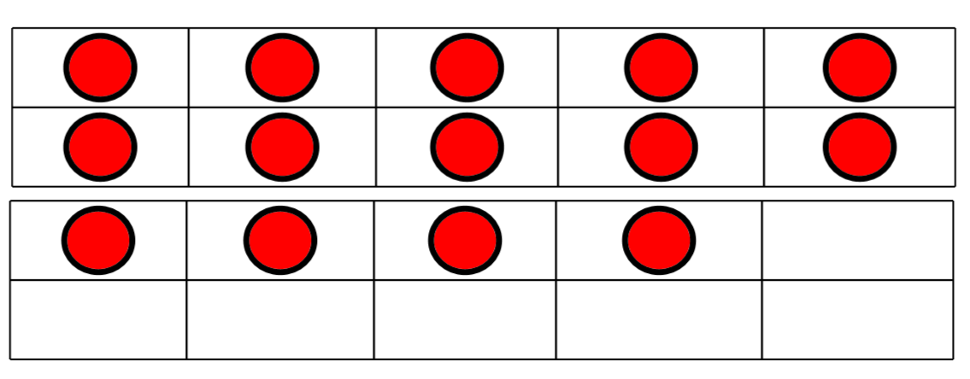

I have



Who has…

