Word Problems

- There are 12 marbles in a box. Some are green. Some are yellow. There are 2 more yellow marbles than green marbles. How many yellow marbles are there?

- Evan had 18 stickers and lost 7. Abby had 16 stickers and lost 9. Who has more stickers left? Explain how you know.

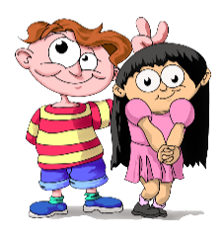
- You have 5¢ left after paying for an item. How much might the item have cost? How much money would you have had originally?

- One number is 3 greater than another. What might the lesser number be? In that case, what would the greater number be? Find at least 3 possible answers.

- There were some children in a group. One other child joined the group and then there were 12. How many children were there first?

- There are 5 children watching a movie. How many eyes are watching?

- Jeff counted 20 legs in the cow barn. How many cows are in the barn? Explain your thinking.

