Representing Numbers to 20
Ten Frame

Tallies 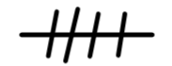
One Less -1 | One More +1
Two Less -2 | Two More +2

Write the Number in Word Form (ex: 19 = nineteen)

Fact Family
(Place the sum in the circle. Ex: 5 + 3 = 8 the number 8 would go in the circle and 5 and 3 would be outside the circle)

Use the following link to access the complimenting SMART lesson: http://stemnorth.nbed.nb.ca/math/document/represent-number-20

