**Representing Numbers to 10**

Ten Frame

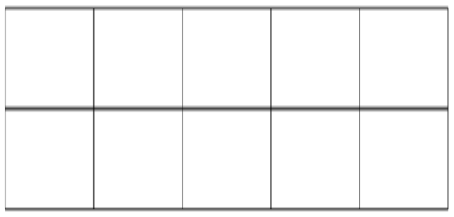

Number After

Number Before

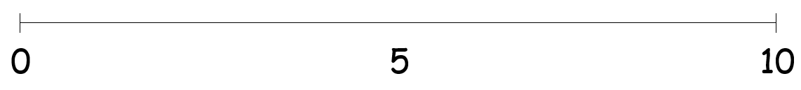

**Part**

**Part**

**Represent a Quantity in two parts**

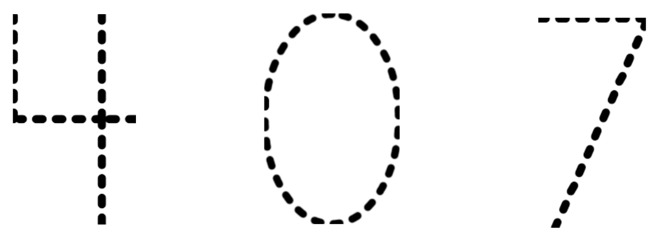

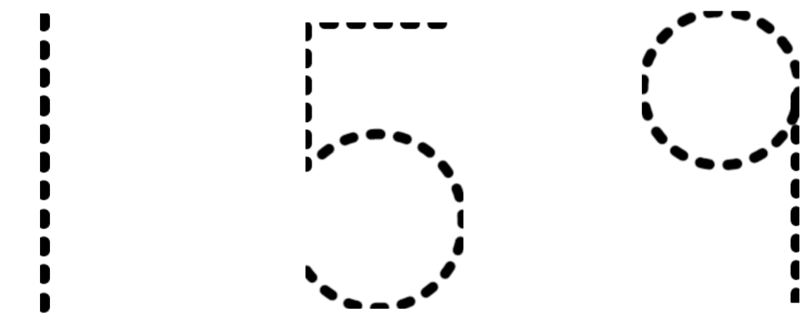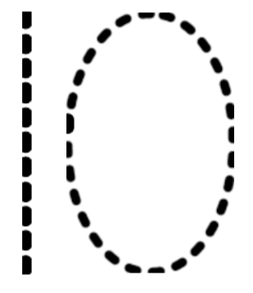

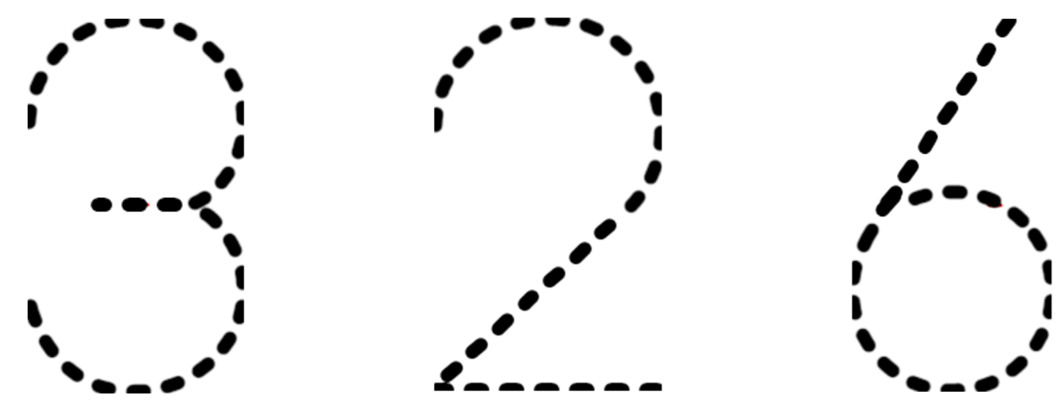 

Use the following link to access the complimenting SMART lesson: <http://stemnorth.nbed.nb.ca/math/document/k-represent-number-10>